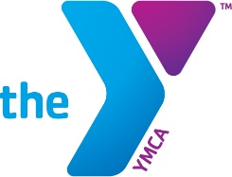
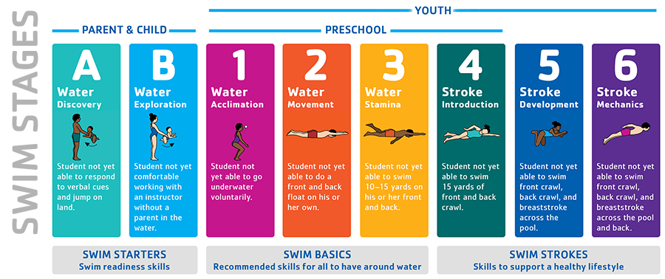

STRONG SWIMMERS CONFIDENT KIDS
Swim Lessons
HOPKINS COUNTY FAMILY YMCA

Nurturing skills and building confidence in the water

For more than 160 years, the YMCA has nurtured potential and united communities across America to create meaningful, lasting change. Everything the Y does is in service of building a better us. One of the most effective ways to accomplish this is to teach youth, teens and adults to swim, so they can stay safe around water and learn the skills they need to make swimming a lifelong pursuit for staying healthy. Swim lessons provide important life skills that could save a life and will benefit students for a lifetime.

INTRODUCING THE SWIM LESSON UPDATE: All participants ages 3 through 12 will take the Swim Skills Assessment at the first class and be placed in the appropriate stage.

STAGE DESCRIPTIONS

A / Water Discovery
Introduces infants and toddlers to the aquatic environment. *Parent & Child

B / Water Exploration
Parents work with children to explore body positions, floating, blowing bubbles and fundamental safety and aquatic skills. *Parent & Child

1 / Water Acclimation
Increased comfort with underwater exploration and introduces basic self-rescue skills performed with assistance.

2 / Water Movement
Encourages forward movement in water and basic self-rescue skills performed independently.

3 / Water Stamina
Develops intermediate self-rescue skills performed at longer distances than in previous stages.

4 / Stroke Introduction
Introduces basic stroke technique in front crawl and back crawl and reinforces water safety through treading water and elementary backstroke.

5 / Stroke Development
Introduces breaststroke and butterfly and reinforces water safety through treading water and sidestroke.

6 / Stroke Mechanics
Refines stroke technique on all major competitive strokes and encourages swimming as part of a healthy lifestyle.

SWIM LESSON SESSION DATES & FEES
Member: $50
Non-Member: $70
Ages 3 through 12

Tuesday/Thursday Evenings
6:15 – 7:00 PM
PLEASE PAY ATTENTION TO SESSION DATES: WE SCHEDULE MAKE-UP DATES AND PLAN AROUND HOLIDAYS, SCHOOL BREAKS & SWIM MEETS

☐ April: 4th, 6th, 11th, 13th, 18th, 20th, 25th, 27th make-up 29thS
(deadline 4/4/23 @ 6pm)
☐ May: 2nd, 4th, 9th, 11th, 16th, 18th, 23rd, 25th make-up 30thT (deadline 5/2/23 @ 6pm)
☐ June: 1st, 6th, 8th, 13th, 15th, 20th, 22nd, 27th make-up 29th (deadline 6/1/23 @ 6pm)

SWIM LESSON REGISTRATION FORM
Name ______________________________________________________________
□ Male □ Female DOB___/___/___ Age_______
□ Asian □ African-American □ Caucasian □Indigenous/Native □ Hispanic/Latino □ Other/Not listed___________________________
□ Member $50 □ Non-Member $70
Ask about financial assistance options at the Welcome Center.
Address____________________________________________________________
City_________________________________________________________________
State_____________ Zip___________________
Parent/Guardian___________________________________________________
Phone__________________________________
Email________________________________________________________________
I, __________________________________________, (Parent/Guardian) of ________________________________ (Participant), do hereby agree to hold free from any and all liability the Hopkins County Family YMCA and its officers, employees and volunteers. I do hereby waive all rights and claims for all injuries or damages incurred. I do declare the participant to be physically sound, having medical approval to participate in the activities of the YMCA Aquatics Program.

_____________________________________________ ____________________
Parent/Guardian Signature Date
We are proud to offer $10 swim lessons to the first 15 participants that sign up each month. Special thanks to the United Way of the Coalfield for their commitment to reducing water related incidents.

INTRODUCING THE SWIM LESSON UPDATE: All participants ages 3 through 12 will take the Swim Skills Assessment at the first class and be placed in the appropriate stage.

The Hopkins County Family YMCA uses photos of program participants in promotional materials and outreach campaigns. Do we have your permission use photos of your child to promote YMCA programs? ☐Yes ☐No

